Ex. No. 1.a: Learn to setup and configure a OpenVPN server

Aim: To Setup and configure an OpenVPN server.

Requirements:
- Linux/Debain (or similar distributions)
- Internet Access
- Sudo access (root/admin rights)

Package Dependencies:
- Openvpn
- Easy-rsa
- Net-tools (for ipconfig/ ip)

Procedure:
- Install OpenVPN and Easy-RSA:

sudo apt update
sudo apt install openvpn easy-rsa -y
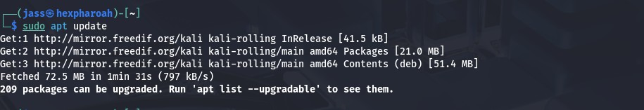
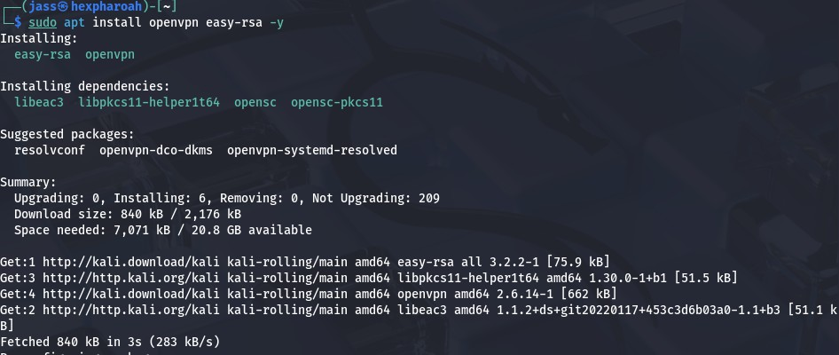
- Set Up Easy-RSA Directory:
make-cadir ~/openvpn-ca cd ~/openvpn-ca
- Initialize the Public Key Infrastructure (PKI):
./easyrsa init-pki
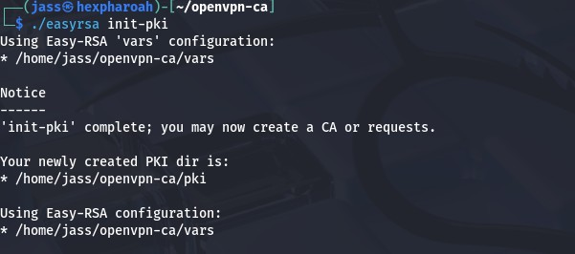

- Build the Certificate Authority (CA):

./easyrsa build-ca
When prompted, enter a name like: MyVPN-CA

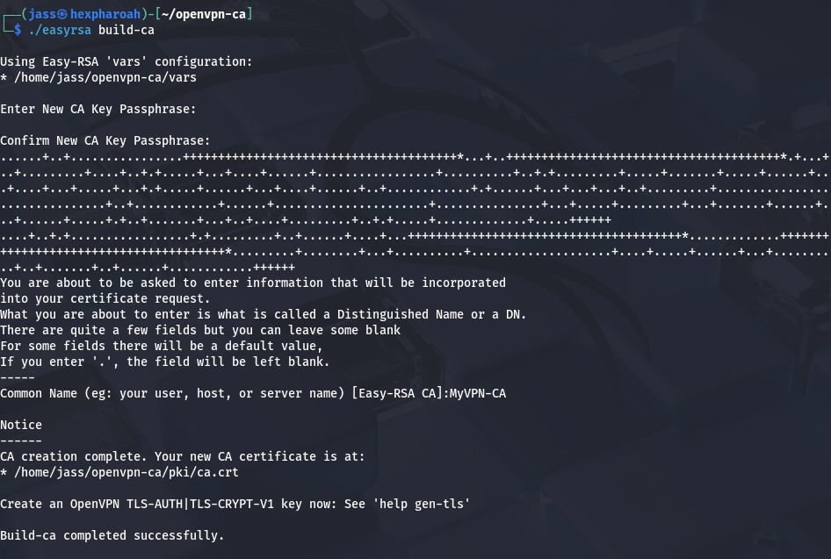
- Generate Server Certificate and Key:

./easyrsa gen-req server nopass
./easyrsa sign-req server server
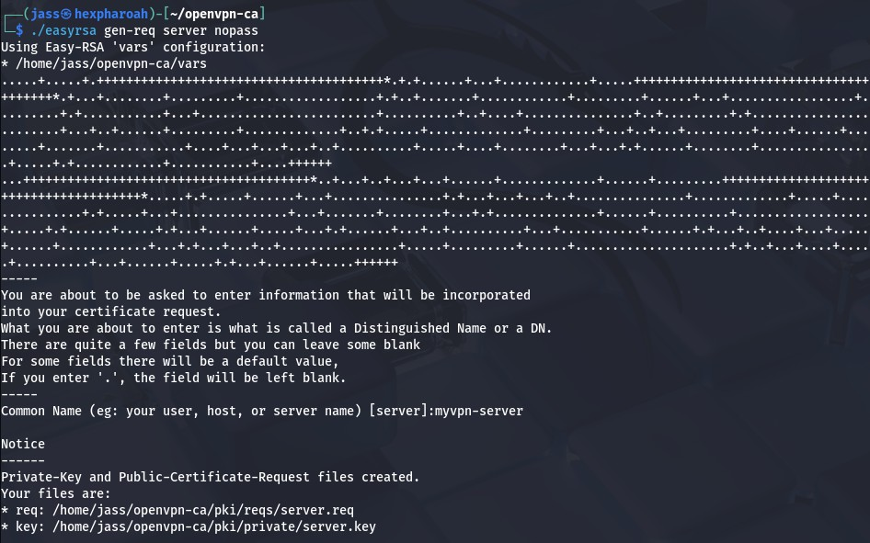
Approve when it asks with: yes

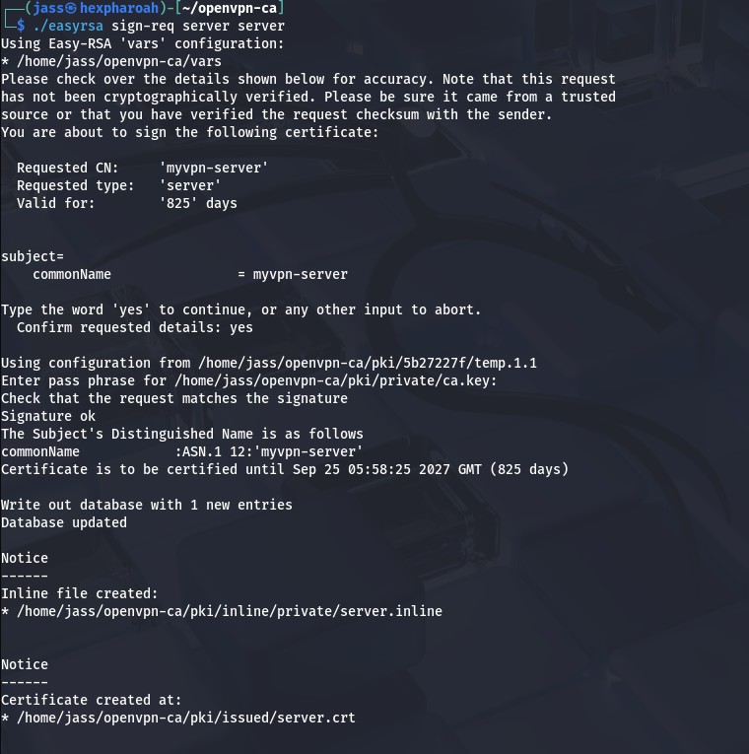
- Generate Diffie-Hellman and TLS Key:

./easyrsa gen-dh
openvpn --genkey secret ta.key

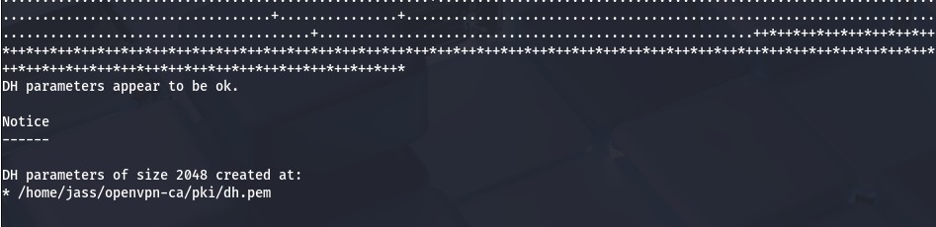
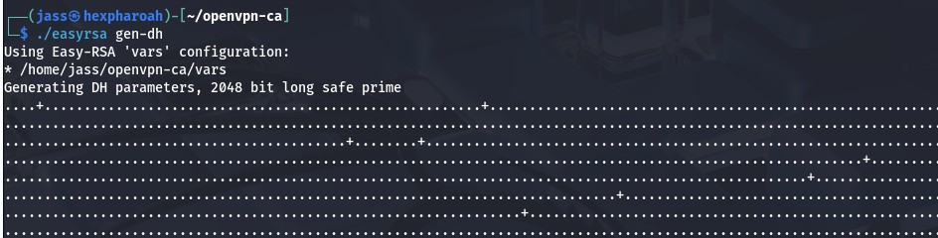

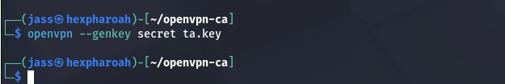
- Copy Keys and Certs to OpenVPN Directory:

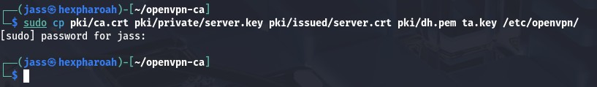
sudo cp pki/ca.crt pki/private/server.key pki/issued/server.crt pki/dh.pem ta.key /etc/openvpn/

- Create Server Configuration File:

sudo nano /etc/openvpn/server.conf
Paste this config: port 1194
proto udp dev tun
ca ca.crt
cert server.crt key server.key

dh dh.pem
tls-auth ta.key
server 10.8.0.0 255.255.255.0
ifconfig-pool-persist ipp.txt
push "redirect-gateway def1 bypass-dhcp" push "dhcp-option DNS 1.1.1.1"
push "dhcp-option DNS 8.8.8.8"
keepalive 10 120 cipher AES-256-CBC user nobody
group nogroup persist-key persist-tun
status openvpn-status.log
log-append /var/log/openvpn.log verb 3
explicit-exit-notify 1
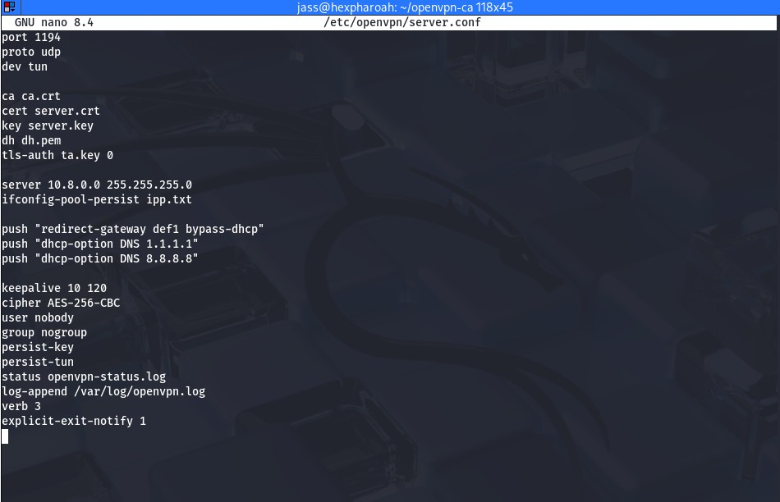

- Enable IP Forwarding:

sudo nano /etc/sysctl.conf
Add:

net.ipv4.ip_forward = 1
Apply the change:

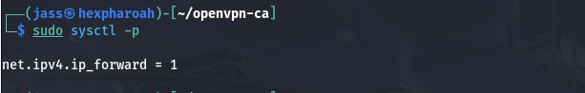
sudo sysctl -p
- Start and Enable OpenVPN Server:

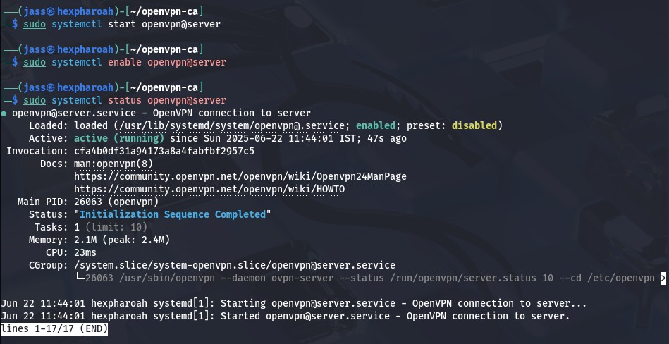
sudo systemctl start openvpn@server sudo systemctl enable openvpn@server sudo systemctl status openvpn@server
Check for tun0 interface: ip a

If you see tun0 with IP 10.8.0.1, the server is up!

Ex. No. 1.b
Generate OpenVPN client configuration flies and connect to server

Aim:
To generate OpenVPN client certificates and configuration files using Easy-RSA, and to establish a secure VPN connection between the client and the OpenVPN server.

Requirements:
- Linux/Debian (or similar distributions) with OpenVPN server already set up
- Internet access or local network connectivity between server and client
- Sudo access (root/admin rights) on the Linux server
- Windows system with OpenVPN GUI installed
- OpenVPN and Easy-RSA must be installed on the Linux server
- Client certificate and key must be generated using Easy-RSA
- Client must be able to successfully connect to the VPN server using the OpenVPN GUI

Procedure:

Generate Client Certificate and Key:
Go to your Easy-RSA directory:

cd ~/openvpn-ca
Run:

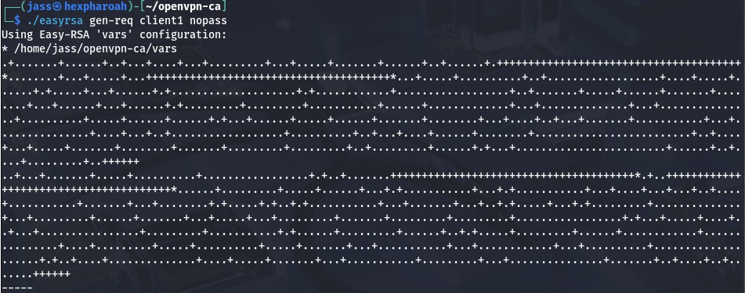
./easyrsa gen-req client1 nopass

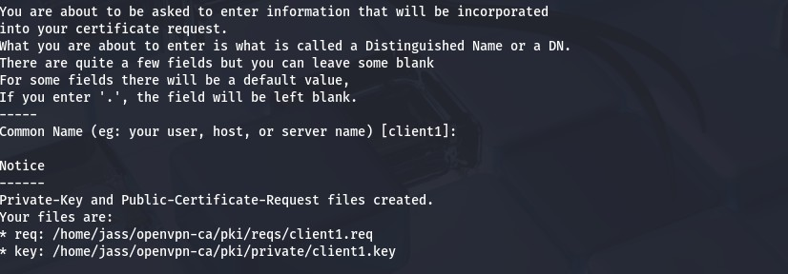

Now sign the request:

./easyrsa sign-req client client1

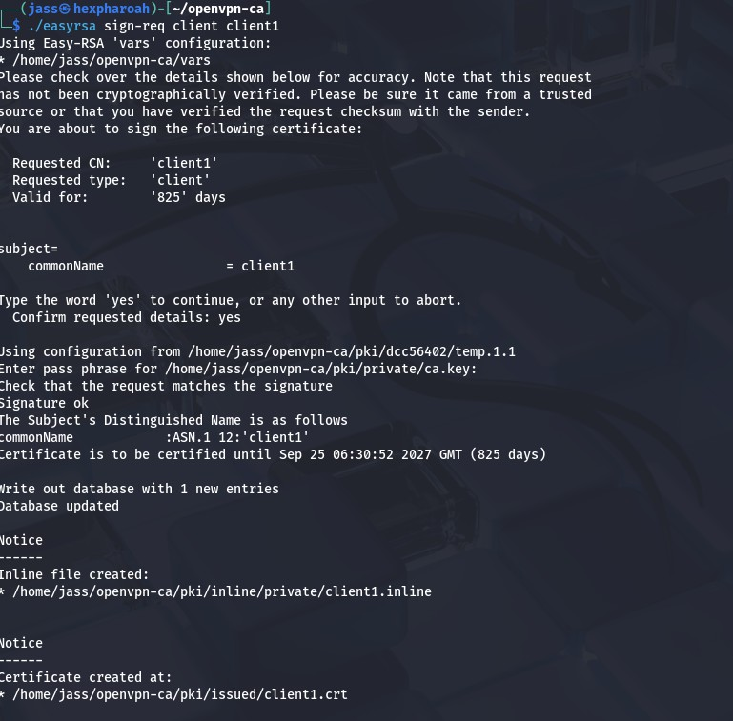
- Copy Required Files:
We need to collect 4 files to build the .ovpn client config, Use this command to copy all into your home folder:

cp pki/issued/client1.crt pki/private/client1.key pki/ca.crt ta.key ~/
- Create ‘client1.ovpn’ Configuration File:
Now create the .ovpn file:

nano ~/client1.ovpn

- Paste this template and replace placeholders:
client dev tun
proto udp
remote YOUR_SERVER_IP 1194 resolv-retry infinite
nobind persist-key persist-tun
remote-cert-tls server cipher AES-256-CBC key-direction 1
verb 3

<ca>
(Paste full contents of ca.crt here)
</ca>

<cert>
(Paste full contents of client1.crt here)
</cert>

<key>
(Paste full contents of client1.key here)
</key>

<tls-auth>
(Paste full contents of ta.key here)
</tls-auth>
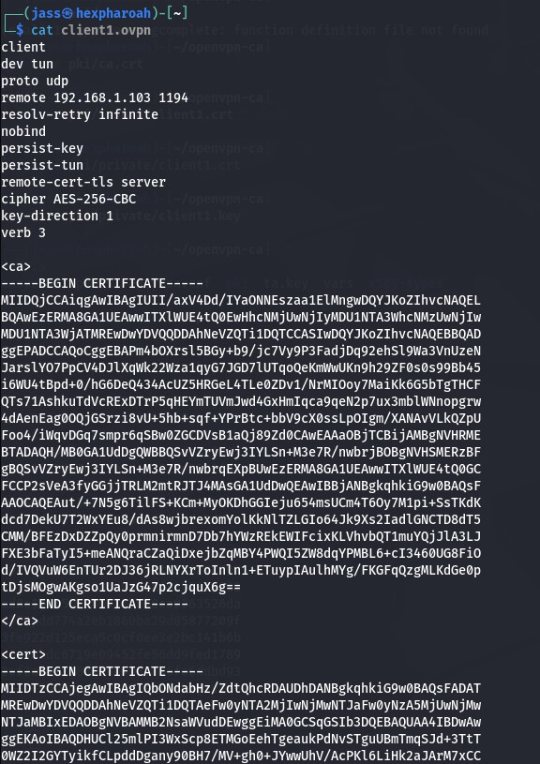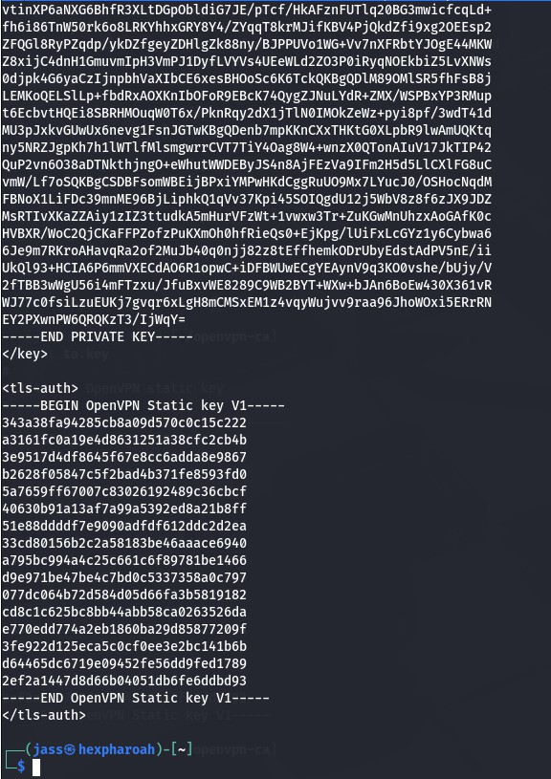

- Transfer client1.ovpn to Your Windows Machine:
  - Install OpenVPN GUI (If Not Done Yet):
    - Download from: https://openvpn.net/community-downloads/
    - Run the installer
    - Make sure to install the TAP driver when prompted

Move client1.ovpn to the Correct Folder:
Move the file to: C:\Program Files\OpenVPN\config using: SCP, USB, File share

Run OpenVPN GUI:
    - Search for OpenVPN GUI
    - Right-click → Run as Administrator
    - OpenVPN won't work without admin rights.

4. Connect to VPN:
    - OpenVPN icon will appear in the system tray (bottom right)
    - Right-click the icon → You’ll see client1
    - Click Connect

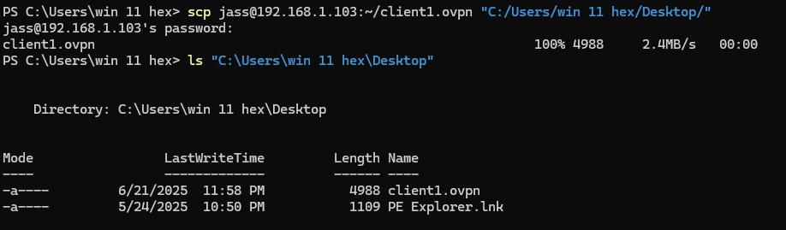

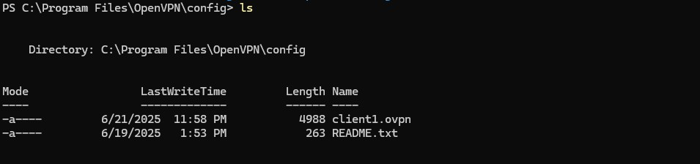

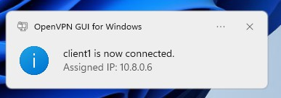
Verify via CMD:
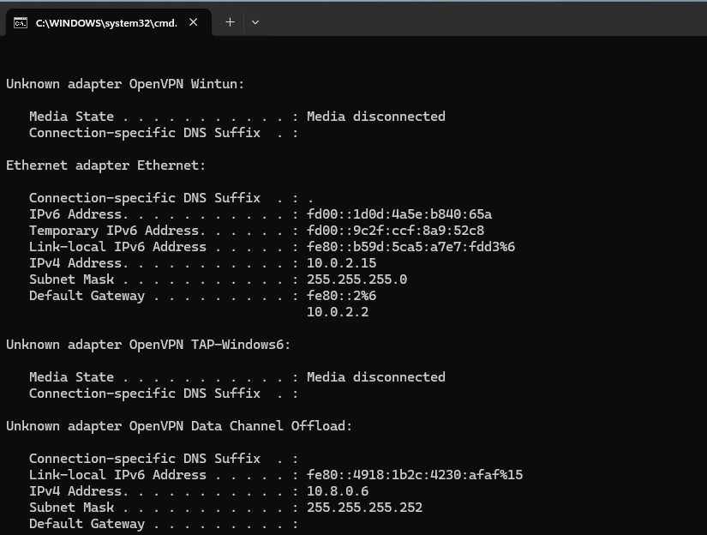

Ex.2.1. Study and setup letsencrypt certiﬁcate (auto renew)

Aim: To install and conﬁgure Let’s Encrypt SSL/TLS certiﬁcates for a domain using Certbot, and enable automatic renewal to ensure continuous HTTPS security.

Introduction:
Let’s Encrypt is a free, automated, and open certiﬁcate authority (CA) that issues SSL/TLS certiﬁcates for enabling HTTPS. It uses the ACME protocol to verify domain ownership and deliver certiﬁcates. Each certiﬁcate is valid for 90 days, making automation and auto-renewal essential.

Importance of SSL/TLS Certiﬁcates:
SSL/TLS certiﬁcates are crucial for securing data transmission between a client and server. They encrypt information such as login credentials, personal details, and payment data, preventing unauthorized access or interception. Let’s Encrypt makes it easier for website owners to implement HTTPS, thereby enhancing user trust and improving SEO rankings, as search engines often prioritize secure websites.

How Let’s Encrypt Works:
Let’s Encrypt operates through domain validation, conﬁrming that the person requesting a certiﬁcate controls the domain name. This veriﬁcation is done using ACME challenges, such as:
- HTTP-01: Uploading a special ﬁle to the server.
- DNS-01: Adding a speciﬁc DNS TXT record.
- TLS-ALPN-01: Using a custom TLS handshake.

Once validation is complete, the CA issues the SSL/TLS certiﬁcate, which can then be installed on the server.

Short Validity and Auto-Renewal:
Unlike traditional CAs, Let’s Encrypt certiﬁcates expire every 90 days. This short lifespan encourages automation, reduces the risk of compromised keys being used long-term, and ensures security best practices are maintained. Without auto-renewal, there is a risk of unexpected certiﬁcate expiry, which can cause downtime and trust issues for visitors.

Automation with ACME Clients:
Certbot is the most widely used ACME client for obtaining and renewing Let’s Encrypt certiﬁcates. It automates the veriﬁcation, issuance, installation, and renewal process. System administrators can integrate Certbot with web servers such as Nginx and Apache, and conﬁgure scheduled tasks (via cron jobs or systemd timers) to automatically renew certiﬁcates before expiry.

Beneﬁts of Let’s Encrypt:
The main advantages of Let’s Encrypt include:

- Free of cost: No fees for certiﬁcates.
- Automation: Reduced manual intervention for issuance and renewal.
- Security: Strong encryption standards and frequent renewals.
- Trust: Widely recognized by browsers and operating systems.
- Adoption: Encourages HTTPS adoption, making the web safer for everyone.

Prerequisites:

- A registered domain name pointing to the server’s public IP.
- Web server installed (Nginx or Apache).
- Open ﬁrewall ports 80 (HTTP) and 443 (HTTPS).
- Root or sudo access to the server.

Procedure:
    - Update system packages: Command : sudo apt update
    - Install the prerequisites:
For nginx users,
Command: sudo apt install nginx
Command: sudo apt install certbot python3-certbot-nginx

For apache users,
Command: sudo apt install apache2
Command: sudo apt install certbot python3-certbot-apache

    - Obtain and install the certiﬁcate:
For Nginx,
Command: sudo certbot --nginx -d example.com -d www.example.com

For Apache,
Command: sudo certbot –apache -d example.com -d www.example.com
    - Verify HTTPS installation:
Command: curl -I https://example.com

    - Enable and test auto-renewal: Command: sudo certbot renew --dry-run
    - Reload web server after renewal: For Nginx,
Command: sudo systemctl reload nginx

For Apache,
Command: sudo systemctl reload apache2

Result:
The Let’s Encrypt SSL/TLS certiﬁcate was successfully installed and conﬁgured for the domain. Auto-renewal has been enabled, ensuring the certiﬁcate will update before expiry without manual intervention. Thus, the setup was completed successfully.

Ex.2.2. Study on iptables and Firewalls in Linux

Aim:
To study and understand the working of iptables as a packet filtering and firewall utility in Linux.
Introduction:
A firewall in Linux acts as a security system that monitors and controls incoming and outgoing network traffic based on predefined rules. The most commonly used firewall tool in Linux is iptables, which is a user-space utility program that allows system administrators to configure the IP packet filter rules of the Linux kernel.
- iptables works on the concept of tables, chains, and rules.
- Tables contain chains, and chains contain rules that match packets and take actions (ACCEPT, DROP, REJECT, LOG).
- It operates at the network and transport layers, making it suitable for packet filtering, NAT (Network Address Translation), and traffic redirection.
Benefits of iptables:
- Enhanced Security – Protects the system from unauthorized access and network attacks.
- Traffic Control – Allows administrators to permit, deny, or reroute traffic as needed.
- Packet Filtering – Filters packets based on IP address, port, protocol, or interface.
- Network Address Translation (NAT) – Enables sharing of a single public IP across multiple devices.
- Flexibility – Supports complex rules for different use cases (firewalling, port forwarding, logging).
- Logging & Auditing – Provides logging of network traffic for analysis.
Prerequisites:
- A Linux system with root/administrative privileges.
- Basic knowledge of networking concepts (IP addresses, ports, protocols).
- Installed package: iptables (by default in most Linux distros, or can be installed via package manager).
Procedure:
- Check iptables installation:
Command: sudo iptables --version
- View current rules:
Command: sudo iptables -L -v -n
- Set default policies: (drop all incoming traffic, allow outgoing)
Command: sudo iptables -P INPUT DROP
sudo iptables -P OUTPUT ACCEPT sudo iptables -P FORWARD DROP
- Allow specific traffic: (allow SSH and HTTP)
Command: sudo iptables -A INPUT -p tcp --dport 22 -j ACCEPT sudo iptables -A INPUT -p tcp --dport 80 -j ACCEPT
- Drop unwanted traffic: (drop ping requests)
Command: sudo iptables -A INPUT -p icmp --icmp-type echo-request -j DROP
- Save the rules: (so they persist after reboot – depends on distro) Command:
On Debian/Ubuntu:
sudo iptables-save > /etc/iptables/rules.v4
On Arch:
sudo iptables-save | sudo tee /etc/iptables/iptables.rules > /dev/null
- Verify rules:
Command: sudo iptables -L -v -n
Rules Explanation:
Default Policies
➔ INPUT (policy DROP)
◆ By default, all incoming traffic is dropped unless explicitly allowed.
◆ This is a secure default because it blocks unknown/unauthorized connections.
➔ FORWARD (policy DROP)
◆ All forwarded packets (used in routing/NAT scenarios) are dropped.
◆ Since this system is not acting as a router, forwarding is disabled.
➔ OUTPUT (policy ACCEPT)
◆ All outgoing traffic is allowed by default.
◆ This means the system can freely initiate connections to the internet.
Configured Rules in INPUT Chain
➔ ACCEPT tcp -- anywhere anywhere tcp dpt:22
◆ Allows incoming SSH connections on port 22.
◆ This is essential for remote administration of the system.
➔ ACCEPT tcp -- anywhere anywhere tcp dpt:80
◆ Allows incoming HTTP traffic on port 80.
◆ This means the system can host a web server and accept requests from clients.
➔ DROP icmp -- anywhere anywhere icmp echo-request
◆ Drops all ICMP echo-requests (ping).
◆ This makes the system invisible to ping probes, improving security by preventing network reconnaissance.
Result:
The iptables firewall was configured with a default DROP policy for inbound traffic. Only SSH (22) and HTTP (80) are allowed, while ICMP echo requests are blocked. Outbound traffic is unrestricted, ensuring security with essential connectivity.

